Computer Systems Lecture 10

Logic Design Overview

Binary digital logic circuits:

* Two voltage levels (ground and supply voltage) for 0 and 1
  + Built from transistors used as on/off switches
  + Analog circuits not very suitable for generic computing
  + Digital logic with more than two states is not practical
* Combinational logic: the output depends only on the current inputs

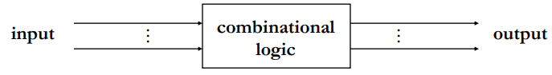

* Sequential logic: output depends on the current inputs as well as previous inputs, this requires memory

Combinational Logic Circuits

Inverter (or NOT gate): 1 input and 1 output, Inverst the input signal

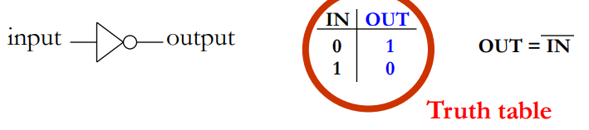

AND gate: 2 inputs and 1 output, output 1 iff both inputs are 1

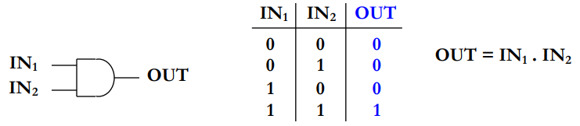

OR gate: output 1 if at least one input is 1

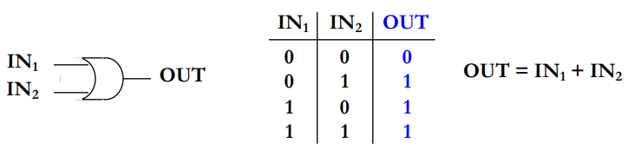

Nor gate: output 1 if no input is 1

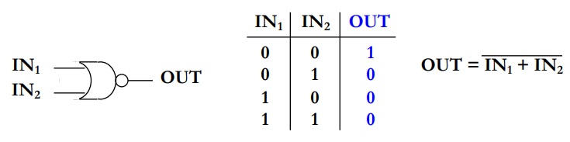

Nand gate: output if both inputs are not 1

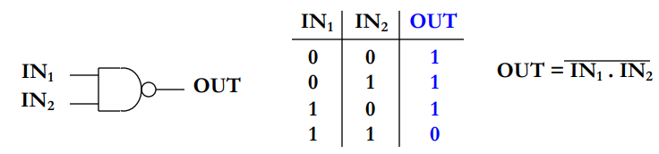

Multiple-input gates:

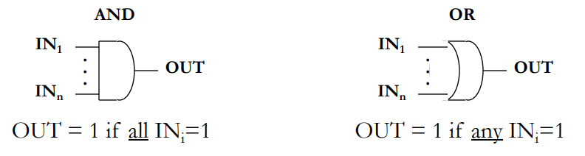

Functional completeness is the term for a set of gates that can be used to express any boolean function.

Some examples of a functionally complete set of gates would be:

AND+OR+NOT

NAND

NOR

Multiplexer

A multiplexer is a circuit for selecting one of multiple inputs:

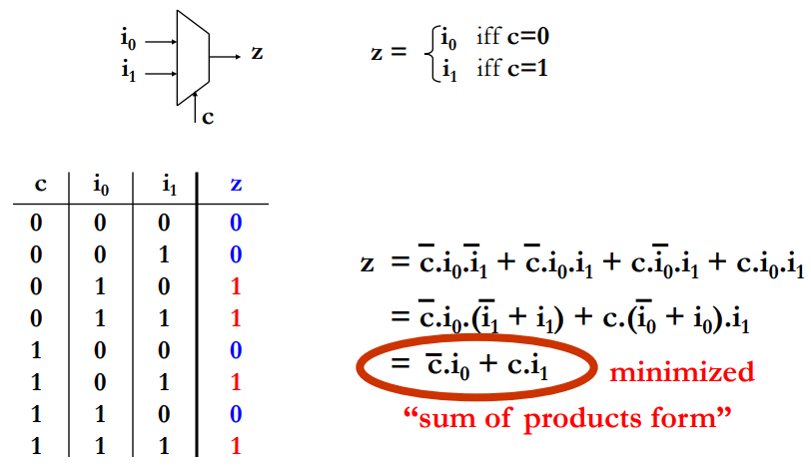

A Multiplexer Implementation

The sum of products form: 

This can be implemented with 1 inverter, 2 and gates and 1 or gate:

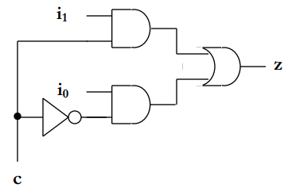

The sum of products is not practical fro circuits with a large number of inputs (n) as the number of possible products can be proportional to 2n

Arithmetic Circuits

32-bit adder:

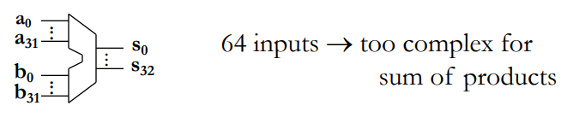

Full adder:

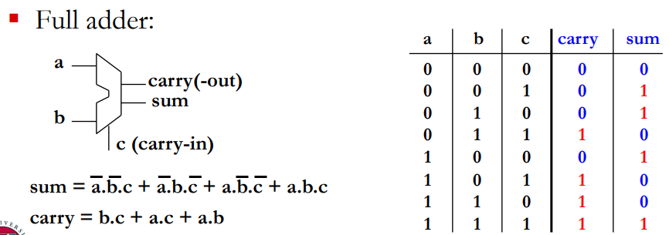

Ripple Carry Adder

The 32-bit adder can be implemented as a chain of 32 full adders where the carry bits feed into the adder for the next bits in the sequence.

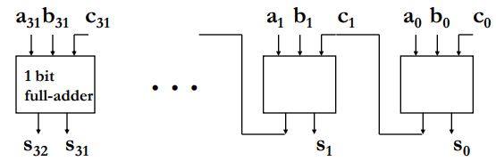

Propagation Delays

Propagation delay is the time delay between input signal change and output signal change at the other end. The delay depends on, the technology being use (transistor parameters, wire capacitance etc…), the delay through each gate (the function of each gate has a different delay) and the number of gates driven by a gate’s output (fan out).

For example a 2-input mux the longest gate path an input need to pass through is NOT -> AND -> OR, meaning there are 3 gate delays before the output is correct.